History

Ver 1.0, 2014-01-24

Summary

This document summary how come map software is sent android map application message to HUD application.

Contents

**1.** Synopsis 2

**2.** Data Structure & define 3

**3.** Icon index 4

# **Synopsis**

Communication method between “Android Map Application” and “HUD Application” is like below

1. two application make “Service” each other
2. “Android Map Application” send data bind with message type (use AIDL)
3. “HUD Application” receives data and send it to HUD device via Bluetooth interface.

Android Device

Map App

HUD App

Service

Service

Bind(AIDL)

Message(data)

# Data Structure

typedef struct  
{

TBT: int // 1st guide icon index

DISTANCE_TBT: int // Remaining distance to 1st guide(m)

NEXT: int // 2nd guide icon index

DISTANCE_NEXT: int // Remaining distance to 2nd guide(m)

SAFE:int // Speed limit camera information

DISTANCE_SAFE: int // Remaining distance to Speed limit camera information(m)

LIMIT: int // Speed Limits (km/h)

SPEED: int // Curent Speed (km/h)

TIME_REMAIN:int // Remaining distance to Destination (m)

DISTANCE_ARRIVAL: int //

}

Example

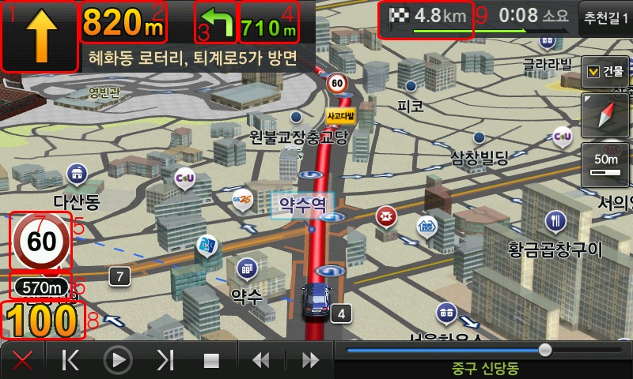

|  |  |  |  |  |  |  |  |  |  |  |  |  |  |  |  |  |  |  |  |  |  |  |  |  |  |  |  |  |  |  |  |  |  |  |  |  |  |  |  |  |  |  |  |  |  |  |  |  |  |  |  |  |  |  |  |  |  |  |  |  |  |  |  |  |  |  |  |  |  |  |  |  |  |  |  |  |  |  |  |  |  |  |  |  |  |  |  |  |  |  |  |  |  |  |  |  |  |  |  |  |  |  |  |  |  |  |  |  |  |  |  |  |  |  |  |  |  |  |  |  |  |  |  |  |  |  |  |  |  |  |  |  |  |  |  |  |  |  |  |  |  |  |  |  |  |  |  |  |  |  |  |  |  |  |  |  |  |  |  |  |  |  |  |  |  |  |  |  |
| --- | --- | --- | --- | --- | --- | --- | --- | --- | --- | --- | --- | --- | --- | --- | --- | --- | --- | --- | --- | --- | --- | --- | --- | --- | --- | --- | --- | --- | --- | --- | --- | --- | --- | --- | --- | --- | --- | --- | --- | --- | --- | --- | --- | --- | --- | --- | --- | --- | --- | --- | --- | --- | --- | --- | --- | --- | --- | --- | --- | --- | --- | --- | --- | --- | --- | --- | --- | --- | --- | --- | --- | --- | --- | --- | --- | --- | --- | --- | --- | --- | --- | --- | --- | --- | --- | --- | --- | --- | --- | --- | --- | --- | --- | --- | --- | --- | --- | --- | --- | --- | --- | --- | --- | --- | --- | --- | --- | --- | --- | --- | --- | --- | --- | --- | --- | --- | --- | --- | --- | --- | --- | --- | --- | --- | --- | --- | --- | --- | --- | --- | --- | --- | --- | --- | --- | --- | --- | --- | --- | --- | --- | --- | --- | --- | --- | --- | --- | --- | --- | --- | --- | --- | --- | --- | --- | --- | --- | --- | --- | --- | --- | --- | --- | --- | --- | --- | --- | --- |
| Icon index  |  |  |  |  | | --- | --- | --- | --- | |  | icon index | Description | picture | | TBT Info | 0 | Go Straight |  | | 1 | Turn Left |  | | 2 | Turn Right |  | | 3 | Turn Left in the 11 o’clock Direction |  | | 4 | Turn Right in the 1 o’clockdirection |  | | 5 | U-Turn to left |  | | 6 | P-Turn |  | | 7 | Turn Right in the 1 o’clock direction |  | | 8 | Right Turn |  | | 9 | Turn Right in the 4 o’clock direction |  | | 10 | Turn Left in the 8 o’clock Direction |  | | 11 | Left Turn |  | | 12 | Turn Left in the 11 o’clock Direction |  | | 13 | Reserved |  | | 14 | Reserved |  | | 15 | At the Roundabout, Take the Exit in the 12 o’clock Direction |  | | 16 | At the Roundabout, Take the Exit in the 9 o’clock Direction |  | | 17 | At the Roundabout, Take the Exit in the 3 o’clock Direction |  | | 18 | At the Roundabout, U-Turn |  | | 19 | At the Roundabout, Take the Exit in the 1 o’clock Direction |  | | 20 | At the Roundabout, Take the Exit in the 4 o’clock Direction |  | | 21 | At the Roundabout, Take the Exit in the 8 o’clock Direction |  | | 22 | At the Roundabout, Take the Exit in the 11 o’clock Direction |  | | 23 | Enter Highway Straight Ahead |  | | 24 | Enter Expressway to the Left |  | | 25 | Enter Expressway to the Right |  | | 26 | Exit Highway |  | | 27 | Exit Highway to the Left |  | | 28 | Exit Highway to the Right |  | | 29 | Enter Overpass Straight Ahead |  | | 30 | Enter Overpass on the Left |  | | 31 | Enter Overpass on the Right |  | | 32 | Enter Main Road on the Left |  | | 33 | Enter Main Road on the Right |  | | 34 | Enter Overpass Straight Ahead |  | | 35 | Enter Overpass on the Left |  | | 36 | Enter Overpass on the Right |  | | 37 | Lane to the Left of Overpass Entrance |  | | 38 | Lane to the Right of Overpass Entrance |  | | 39 | Enter UnderpassStraight Ahead |  | | 40 | Enter Underpass on the Left |  | | 41 | Enter Underpass on the Right |  | | 42 | Enter the Left of Underpass |  | | 43 | Enter the Right of Underpass |  | | 44 | Enter Tunnel (Highway) |  | | 45 | Enter Tunnel( Road) |  | | 46 | Enter Bridge (High way) |  | | 47 | Enter Tunnel (Road) |  | | 48 | Expressway Rest Area |  | | 49 | Enter Express Rest Area on the Right |  | | 50 | Tollgate |  | | 51~102 | reserved |  | | 103 | Near Destination |  | | Speed limit camera information. | 141 | Speed Camera |  | |